|  |  |  |  |  |
| --- | --- | --- | --- | --- |
| Fecha | Versión | Incidencias | Entrega | Comentario |
| 13/12/2022 | Inicial | 3 | 13/12/2022 13:04 | No se ve el botón cancelar. Ajustar tamaño |
| 22/12/2022 | v.2 | 3 | 21/12/2022 | No se muestran correctamente los datos. Error al entrar en algunos casos. |

**PANTALLA DETALLE SCRIPT**

1. Salen intercambiados el tipo de acción padre y el tipo de acción. En los campos Acción, el de la izquierda debe ser tip_accion_padre y el de la derecha tip_accion (devueltos por p_detalle_objetos_scripts en la estructura t_t_det_objeto)

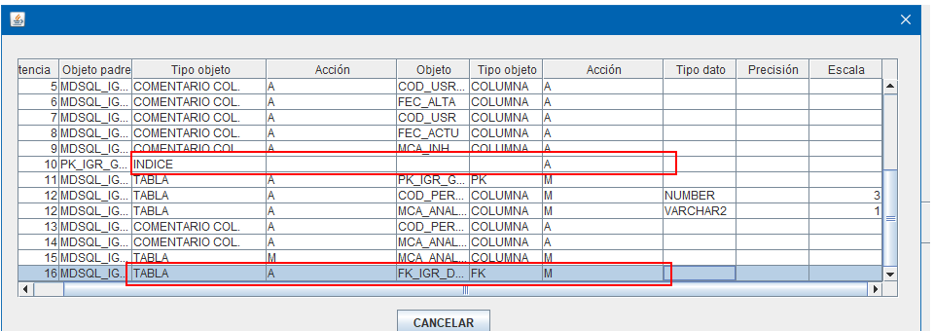

1. Están cambiados la precisión y escala. Están cambiados la precisión y escala

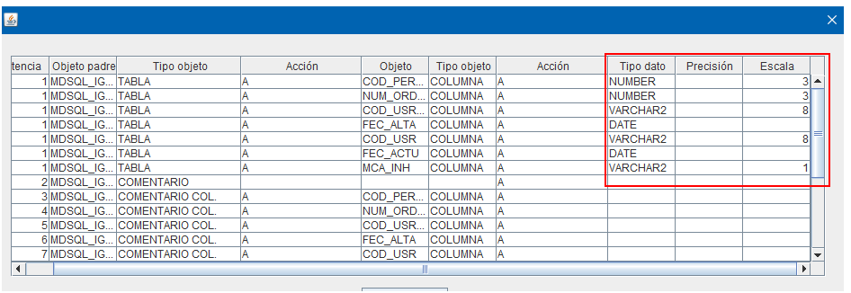

1. En una de las pruebas se ha producido este error:

13:16:46.345 [AWT-EventQueue-0] INFO  c.m.b.service.impl.ServiceSupport - {call SM2_K_LD_MDSQL.P_DETALLE_OBJETOS_SCRIPTS(?,?,?,?,?)}

13:16:46.346 [AWT-EventQueue-0] INFO  c.m.b.service.impl.ServiceSupport - Parßmetros de entrada:

        529

        1

Exception in thread "AWT-EventQueue-0" java.security.PrivilegedActionException: java.security.PrivilegedActionException: com.mdval.exceptions.ServiceException

        at java.security.AccessController.doPrivileged(Native Method)

        at java.security.ProtectionDomain$JavaSecurityAccessImpl.doIntersectionPrivilege(Unknown Source)

        at java.awt.EventQueue.dispatchEvent(Unknown Source)

        at java.awt.EventDispatchThread.pumpOneEventForFilters(Unknown Source)

        at java.awt.EventDispatchThread.pumpEventsForFilter(Unknown Source)

        at java.awt.EventDispatchThread.pumpEventsForFilter(Unknown Source)

        at java.awt.WaitDispatchSupport$2.run(Unknown Source)

        at java.awt.WaitDispatchSupport$4.run(Unknown Source)

        at java.awt.WaitDispatchSupport$4.run(Unknown Source)

        at java.security.AccessController.doPrivileged(Native Method)

        at java.awt.WaitDispatchSupport.enter(Unknown Source)

        at java.awt.Dialog.show(Unknown Source)

        at java.awt.Component.show(Unknown Source)

        at java.awt.Component.setVisible(Unknown Source)

        at java.awt.Window.setVisible(Unknown Source)

        at java.awt.Dialog.setVisible(Unknown Source)

        at com.mdval.ui.utils.UIHelper.show(UIHelper.java:63)

        at com.mdsql.ui.listener.FramePrincipalActionListener.evtEjecutar(FramePrincipalActionListener.java:410)

        at com.mdsql.ui.listener.FramePrincipalActionListener.actionPerformed(FramePrincipalActionListener.java:99)

        at javax.swing.AbstractButton.fireActionPerformed(Unknown Source)

        at javax.swing.AbstractButton$Handler.actionPerformed(Unknown Source)

        at javax.swing.DefaultButtonModel.fireActionPerformed(Unknown Source)

        at javax.swing.DefaultButtonModel.setPressed(Unknown Source)

        at javax.swing.plaf.basic.BasicButtonListener.mouseReleased(Unknown Source)

        at java.awt.AWTEventMulticaster.mouseReleased(Unknown Source)

        at java.awt.Component.processMouseEvent(Unknown Source)

        at javax.swing.JComponent.processMouseEvent(Unknown Source)

        at java.awt.Component.processEvent(Unknown Source)

        at java.awt.Container.processEvent(Unknown Source)

        at java.awt.Component.dispatchEventImpl(Unknown Source)

        at java.awt.Container.dispatchEventImpl(Unknown Source)

        at java.awt.Component.dispatchEvent(Unknown Source)

        at java.awt.LightweightDispatcher.retargetMouseEvent(Unknown Source)

        at java.awt.LightweightDispatcher.processMouseEvent(Unknown Source)

        at java.awt.LightweightDispatcher.dispatchEvent(Unknown Source)

        at java.awt.Container.dispatchEventImpl(Unknown Source)

        at java.awt.Window.dispatchEventImpl(Unknown Source)

        at java.awt.Component.dispatchEvent(Unknown Source)

        at java.awt.EventQueue.dispatchEventImpl(Unknown Source)

        at java.awt.EventQueue.access$500(Unknown Source)

        at java.awt.EventQueue$3.run(Unknown Source)

        at java.awt.EventQueue$3.run(Unknown Source)

        at java.security.AccessController.doPrivileged(Native Method)

        at java.security.ProtectionDomain$JavaSecurityAccessImpl.doIntersectionPrivilege(Unknown Source)

        at java.security.ProtectionDomain$JavaSecurityAccessImpl.doIntersectionPrivilege(Unknown Source)

        at java.awt.EventQueue$4.run(Unknown Source)

        at java.awt.EventQueue$4.run(Unknown Source)

        at java.security.AccessController.doPrivileged(Native Method)

        at java.security.ProtectionDomain$JavaSecurityAccessImpl.doIntersectionPrivilege(Unknown Source)

        at java.awt.EventQueue.dispatchEvent(Unknown Source)

        at java.awt.EventDispatchThread.pumpOneEventForFilters(Unknown Source)

        at java.awt.EventDispatchThread.pumpEventsForFilter(Unknown Source)

        at java.awt.EventDispatchThread.pumpEventsForHierarchy(Unknown Source)

        at java.awt.EventDispatchThread.pumpEvents(Unknown Source)

        at java.awt.EventDispatchThread.pumpEvents(Unknown Source)

        at java.awt.EventDispatchThread.run(Unknown Source)

Caused by: java.security.PrivilegedActionException: com.mdval.exceptions.ServiceException

        at java.security.AccessController.doPrivileged(Native Method)

        at java.security.ProtectionDomain$JavaSecurityAccessImpl.doIntersectionPrivilege(Unknown Source)

        at java.security.ProtectionDomain$JavaSecurityAccessImpl.doIntersectionPrivilege(Unknown Source)

        at java.awt.EventQueue$4.run(Unknown Source)

        at java.awt.EventQueue$4.run(Unknown Source)

        ... 56 more

Caused by: com.mdval.exceptions.ServiceException

        at com.mdsql.bussiness.service.impl.ServiceSupport.buildException(ServiceSupport.java:64)

        at com.mdsql.bussiness.service.impl.ServiceSupport.buildException(ServiceSupport.java:46)

        at com.mdsql.bussiness.service.impl.ScriptServiceImpl.detalleObjetosScripts(ScriptServiceImpl.java:749)

        at com.mdsql.ui.listener.PantallaDetalleScriptListener.onLoad(PantallaDetalleScriptListener.java:58)

        at com.mdval.ui.utils.DialogSupport.initialize(DialogSupport.java:100)

        at com.mdval.ui.utils.DialogSupport.<init>(DialogSupport.java:77)

        at com.mdsql.ui.PantallaDetalleScript.<init>(PantallaDetalleScript.java:47)

        at com.mdsql.ui.utils.creators.DialogCreator.factoryMethod(DialogCreator.java:100)

        at com.mdsql.ui.utils.MDSQLUIHelper.createDialog(MDSQLUIHelper.java:41)

        at com.mdsql.ui.listener.PantallaEjecutarScriptsListener.eventBtnDetalleScript(PantallaEjecutarScriptsListener.java:139)

        at com.mdsql.ui.listener.PantallaEjecutarScriptsListener.actionPerformed(PantallaEjecutarScriptsListener.java:64)

        at javax.swing.AbstractButton.fireActionPerformed(Unknown Source)

        at javax.swing.AbstractButton$Handler.actionPerformed(Unknown Source)

        at javax.swing.DefaultButtonModel.fireActionPerformed(Unknown Source)

        at javax.swing.DefaultButtonModel.setPressed(Unknown Source)

        at javax.swing.plaf.basic.BasicButtonListener.mouseReleased(Unknown Source)

        at java.awt.Component.processMouseEvent(Unknown Source)

        at javax.swing.JComponent.processMouseEvent(Unknown Source)

        at java.awt.Component.processEvent(Unknown Source)

        at java.awt.Container.processEvent(Unknown Source)

        at java.awt.Component.dispatchEventImpl(Unknown Source)

        at java.awt.Container.dispatchEventImpl(Unknown Source)

        at java.awt.Component.dispatchEvent(Unknown Source)

        at java.awt.LightweightDispatcher.retargetMouseEvent(Unknown Source)

        at java.awt.LightweightDispatcher.processMouseEvent(Unknown Source)

        at java.awt.LightweightDispatcher.dispatchEvent(Unknown Source)

        at java.awt.Container.dispatchEventImpl(Unknown Source)

        at java.awt.Window.dispatchEventImpl(Unknown Source)

        at java.awt.Component.dispatchEvent(Unknown Source)

        at java.awt.EventQueue.dispatchEventImpl(Unknown Source)

        at java.awt.EventQueue.access$500(Unknown Source)

        at java.awt.EventQueue$3.run(Unknown Source)

        at java.awt.EventQueue$3.run(Unknown Source)

        ... 61 more